**Target Audience**

**Project exam 1. Christian Skilbred Larsen Noroff 2020**

**This document includes my target audience, personas, storyboard, wireframe and link to my adobe XD prototype.**

**Adobe XD Prototype:**

<https://xd.adobe.com/view/aa1320d2-66c7-44e3-61cc-d3204477e208-dc22/>

This prototype is almost how I imagine it will look like. I will be adding more “animations” to buttons, nav and maybe also to some image or content. Also try to use some gradient with rgba color, if it looks good. For tablet view it will look the same as the desktop view when it comes to the body, but for navigation it will have a drop down, hamburger menu. And the footer will look the same as on mobile. So, you can get a good view on how it will look on tablet. In the prototype I have made for desktop and phone. (the view mobile and desktop button will not be on the finish product, it’s just for navigation in XD)

My target audience for this site will ideally be astronauts and employees in the SpaceX program. The site is open for everyone, so will also focus on people between age 25-35/40. The best place for me to find an audience will be people I know are interested, in the space program, or in schools that educates future space employees. Will try my best to find suitable candidates, or worst case I will need to use myself.

**Create my audience:**

Before I can create content that resonates, it helps to know my audience (as well as who they are not). An audience definition should ideally connect these three things:

* Your product or service
* Your main audience demographic
* Your contents mission

**So, to give you an example:**

***“(your brand)*** *creates content to help and inform* ***(demographic)*** *so they can* ***(action)*** *better.”*

SpaceX microsite creates content to help and inform the user so they can learn and understand better.

*“Talk about what your audience cares about (not yourself)”*

**When I have my audience, here is what I need to know:**

* Who – who is you’re audience? Who are you to them?
* What – what do they want from your site.
* Why – why do they need this site, or why should they use your site.

**It is also good to get some specific details, this ca be:**

* Gender
* Goals
* Age
* Job title
* Location
* Needs
* Pain points

**Storyboards:**

Story 1

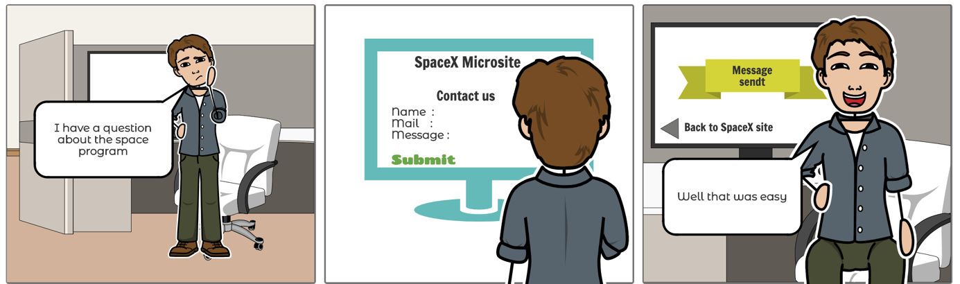

Story 2

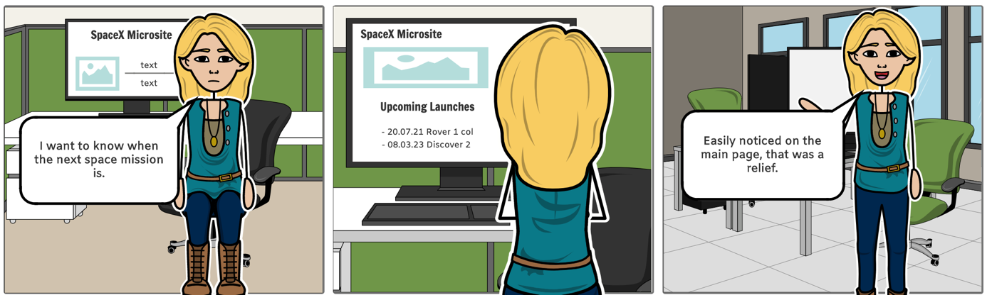

Story 3

**Personas:**

**Wireframe:**

Here I have some wireframe that I started with, I then switched to making a prototype when I understood that we did not need to do both. But since I started with the wireframe I will post what I made underneath.

